The Unlimited Path of Healing: Exploring the potential of Regeneration Healing

This method of applied healing processes is focused on bringing about desired results, both for the individual user and the healing practitioner. Healing honors a person’s freewill while bringing about the best possible results. It allows you to enable visible shifts in the physical world through your expansion of consciousness. The healing emphasis is on your role as a positive, Self-affirmative co-creator of your reality, and your innate ability to readily activate the intended changes.

RE:
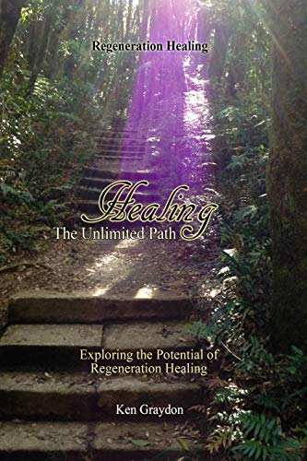

I welcome you to your first or continued healing experience
of this disentanglement process!

60-minute session @ $100.00
For bookings contact Achmed
6.2Navig8or@protonmail.com
Or (808) 990-4622

Regeneration Healing is a compilation of modalities which attracts a series of healing probabilities from regeneration of organs, teeth and/or other body parts through life-style changes, even animal healing to blessings of land or weather changes.
For people-oriented healing, the overall intention is that a client will attain the physical, mental, emotional, and spiritual standard that they and the Creator had planned for them to have at this stage of their life.
Regeneration Healing works equally well face-to-face, as it does remotely to the other side of the world.

This work is not new
The idea of regeneration and other amazing healing has been part of the sacred literature of most of the world’s spiritual traditions.
These processes exist in the space where quantum physics meets the spirit world; they bring about a new reality of health and harmony, enabling you to access the pattern of the original matrix of information, the Creator’s pattern and an understanding of the inter-connectedness of all life to remake your own life to the original intended version, in effect to change your world through consciousness.

The Place of Knowing
The key intention for all the work within the scope of the Regeneration Healing area is to attain the physical, mental, emotional and spiritual state that you and the Creator had planned for you to have in the here and now.
Every other healing intention is simply a part of the knowledge that any illness has the potential to be healed instantly.

Key Points to the Processes

Key phrase
Each process starts with a key phrase: ‘I connect with the Source and Center of all Creation, the source of all healing’. Or you may substitute this particular phrase for one that you can relate to; it is intended to acknowledge a creative power sustaining the infinite plasma fields contained in the Multiverse.

Share point
Sharing your personal gift of healing is a simple acknowledgment of a very profound truth. There is no self-centered intention, whatever personal issue you are addressing will impact all of life as all is interconnected and each healing adds to the collective healing available on Earth.

Intention
The next statement is ‘My intention for this healing’ – where sometimes we will use your primary intention, which is – ‘to attain the physical, mental, emotional and spiritual health that we and the Creator had planned for you to have at this stage of your life.’
At other times, we will use very specific intentions for the individual client. This is a very intuitive process and if your intentions are correct for you, you cannot go wrong with this process.
We know that now is the only time there is, despite our soul’s time-travelling.
In the process here, we go back to ‘ A time before the event that triggered the ……’ whether it was an illness, an accident or some unpleasant happening you choose to address and redress.
Your soul will then ‘change this past event’ so that both the present and the future are changed.
Your soul will decide not to be independent, but to ‘follow the illumined path of your spiritual purpose and destiny’.
In other words, to do what you and the Creative Life Force had planned for you, instead of another choice, that caused your problem.
This then results in a different situation. What about other people’s participation in the initial deviation from your soul’s trajectory creating the undesirable events? We can change that, too, in our current reality: ‘The other events and participants go their own way.’
Our lives are not unalterably entangled. So, if you decide an event did not happen, neither the other people had it happen with us involved. You are releasing them and your Self from any sense of contrived entanglement.

